Regular Expressions and Finite Automata_Dyka Adlero Clifzier Holy Covenant
Week 11
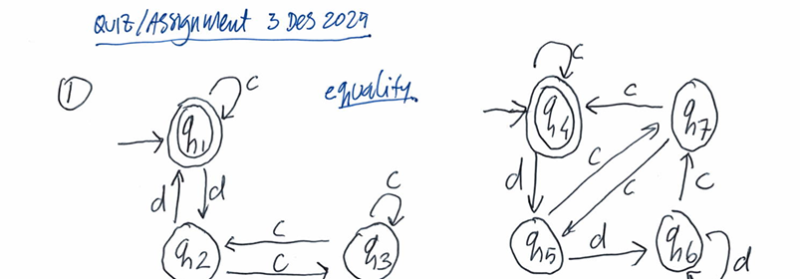
The equivalence of the finite automata 1 and 2 is shown proving they accept the same language. Both recognizes string. But they don’t provide the same output.
Verify:
Start: Input: Next state:
{q1&q4} C {q1&q4}= All final state
{q1&q4} D {q2&q5}= All intermediate state
{q2&q5} C {q3&q7} = All intermediate state
{q2&q5} D {q1&q6} = Differing states state
Conclusion: FA1 and FA2 is not equivalent.

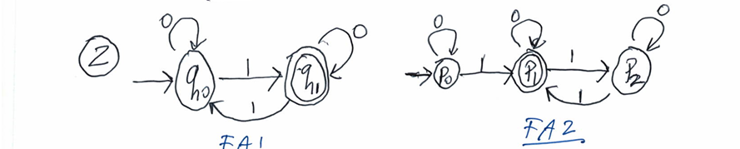
Verify:
Start: Input: Next state:
{q0&p0} 0 {q0&p0}= All intermediate state
{q0&p0} 1 {q1&p1}= All final state
{q1&p1} 0 {q1&p1} = All final state
{q1&p1} 1 {q0&p2} = All intermediate state
{q0&p2} 0 {q0&p2} = All intermediate state
{q0&p2} 1 {q1&p1} = All final state
Conclusion: FA1 and FA2 is equivalent.
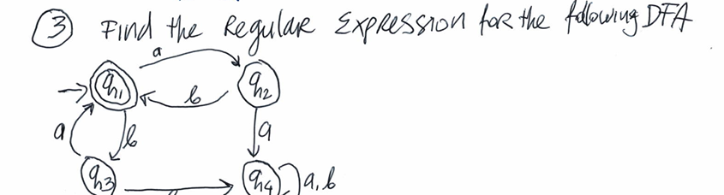
Regular expression: (ab|ba)*

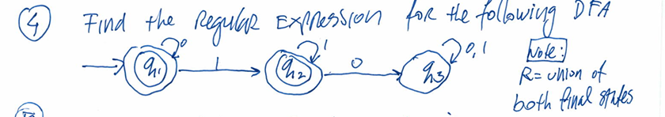
Regular Expression: 0*1*

